**Artificial Intelligence 2**

**Past Paper exam notes**

**Question**

**What is supervised machine learning?**

**Answer**

Supervised Machine Learning techniques automatically learn a model of the relationship between a set of descriptive features and a target feature from a set of historical examples.

Based on the stationarity assumption – the data doesn’t change.

**Question**

**Explain what can go wrong when a machine learning classifier uses the wrong inductive bias?**

**Answer**

When a machine learning classifier uses the wrong inductive bias, it can lead to

* Underfitting occurs when a statistical model or machine learning algorithm cannot capture the underlying trend of the data.
* Overfitting occurs when a model is excessively complex, such as having too many parameters relative to the number of observations.

**Question**

**Explain what is meant by inductive learning?**

**Answer**

Inductive learning is a powerful strategy for helping students deepen their understanding of content and develop their inference and evidence-gathering skills.

* Find patterns.

**Question**

**Inductive machine learning is often referred to as an ill-posed problem. What is meant by this?**

**Answer**

Machine Learning is an ill-posed problem

* Generalize
* Inductive bias
* Underfitting
* Overfitting

**Question**

**Explain what is meant by the term inductive bias and illustrate your explanation using examples of inductive biases used by machine learning algorithms?**

**Answer**

Inductive bias is the set of assumptions that define the model selection criteria of a Machine Learning algorithm.

There are two types of bias that we can use

* **Restriction bias** is an inductive bias where some hypothesis are preferred over others.
* **Preference bias** is an inductive bias where the set of hypothesis considered is restricted to a smaller set.

**Confusion Matrix**

**True Positive (TP)**

**True Negative (TN)**

**False Positive (FP)**

**False Negative (FN)**

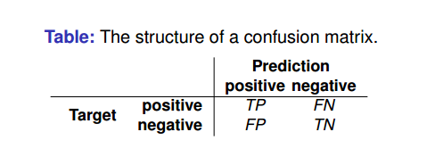

**Smoothing takes some of the probability from the events with lots of the probability shares and gives it to the other probabilities in the set.**

**Question**

**Given a choice between the Patrons and Type feature, which feature would ID3 algorithm choose as the root node for a decision tree?**

**Answer**

**You pick the feature with the greater information node as the the root node.**

**For example if they had information gains of Patrons = 0.1 and Type = 1 . The root node would be Type since it is greatet than Patrons**